**Company Profile**

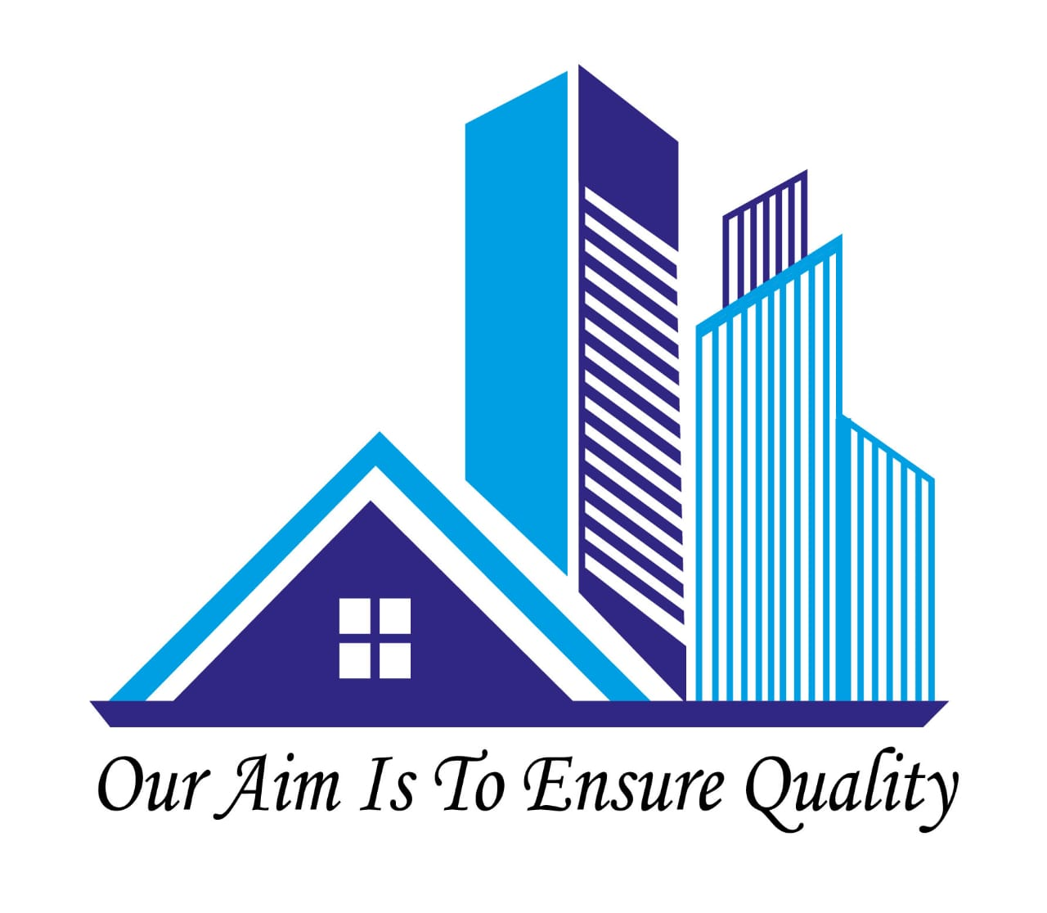



**TRUST ENGINEERING & CONSTRUCTION**

**www.** **teconstruction.xyz**

**House No-145(1st Floor), Road #4, Mohakhali DOHS**

**Dhaka-1206, Bangladesh**

**Mobile: +8801813854538**

**+8801980122136**

**Email:** [**info@teconstruction.xyz**](mailto:info@teconstruction.xyz)

**Contents**

1.0 General Information about the company…………………..………...4

2.0 Brief Description of the Firm…………………………………………...4

2.1 Background……………………………………………………………...4

2.2 About Us…………………………………………………………………4

2.3 Our Mission……………………………………………………………...5

2.4 Our Vision ……………………………………………………………..6

3.0 Our Services…………………………………………………………….6

3.1 Consultancy……………………………...……………………………...6

3.2 Building Design………………………………………….……………...6

3.3 Architectural Design……………………………………….…………...7

3.4 3d Visualization………………………………………………….……...7

3.5 Interior Design……………………………………………….………….7

3.6 Structural Design……………………………………………………….7

3.7 Foundation design………………………………………………..…….8

3.8 Safety/Compliance Requirements………………………………..…..8

3.8.1 Fire Detection/Protection System Design…………………………...8

3.9 Electrical Design…………………………………………………...…..8

3.10 Plumbing Design…………………………………………………..……9

3.11 Engineering Surveys ………………………………………………..…9

3.12 BOQ ………………………………………………………..………......10

4.0 The Practice ………………………………………………………......10

5.0 Field of activities ………………………………………………….…..10

6.0 Equipment Facilities…………………………………………………..10

6.1 List of Work Done Project…….……………………………………...12

6.2 List of Work Done Project…………………………………………...14

6.3 List of Work Done Project…………………………………………...15

7.0 Management Team ………………………………………………….16

8.0 List of Trust Engineering & Construction Manpower……………..17

**1.0 General Information about the company**

Name of the Company : Trust Engineering and Construction

Type of Company : Engineering Construction and consultancy

Date of Establishment : 2019

Trade License : TRAD/DNCC/003338/2021

Vat Reg. Number : 005209387-0101

TIN. : 132303346581

Corporate Office : 1st Floor, House #145, Road # 4, Mohakhali

DOHS.

Tel : 01813854538

Email : info@teconstruction.xyz

Website : www.teconstruction.xyz

**2.0 BRIEF DESCRIPTION OF THE FIRM**

**2.1 Background**

Trust engineering and construction was established in the year 2019 by a group of young and retired engineers to serve the private sector of Bangladesh with engineering design, Construction, consultancy and supervision services. This company was started with designs and construction that is not only aesthetically beautiful but also practical and cost effective.

**2.2 About Us**

TEC, has been formed based on the principle to provide quality service at any cost. Here in TEC, we strictly adhere to building codes and safety regulations to ensure safety of the structures we design and hence safety of the clients we work for. Our goal is to become the industry leaders in architectural and engineering design.

TEC is the association of group of engineers and architects. Our engineers and architects come from universities like BUET and others with experience of working for both international/national consultancy and construction firm. Also highly experienced engineer from public service like retired people of PWD. Our experience ranges from creating and assisting in many types of design construction.

Our strategy is to develop good concepts and designs to help people make the best possible solutions out of their starting ideas. Here in TEC, we provide aids like detailed drafts and drawings, visualization (in form of realistic 3D renders) to help projects be more understandable by authors, best represented to wider audience, and used as a marketing solution to the potential customers.

One of our key Capability is to ensure compliance requirements of building design and construction. Our professionals have experience of developing buildings design and construction complying with fire, electrical and building safety standards. Other key services offered by TEC includes.

* Architectural design.
* Structural design.
* Foundation design.
* Plumbing design.
* Electrical layout and systems design.
* BOQ Preparation.
* Interior Design and Construction.
* Engineering Surveys.

TEC has been working on both industrial and residential sector of Bangladesh from the beginning. Some of our completed and ongoing projects can be seen here.

**2.3 Our Mission**

The mission of TEC Consultants is:

* Provide quality service on time.
* Design and construction eco-friendly structures while Optimizing costs.
* To make cost-effective designs that precisely matches the standards codes of structure without compromising the quality and aesthetic beauty of the project.

**2.4 Our Vision**

* The Visions of TEC Consultants are:
* Become pioneer in engineering design and construction services
* Use cutting edge technology to design and implement iconic structures
* Develop the company into a research-based firm

**3.0 Our Services**

Every project represents a unique, creative challenge

**3.1 Consultancy**

Construction of 10 storied Residential building Tejkonipara, Tejgoan, Dhaka, Gazipur, Construction of 9-storied Residential Madrasah building, Amin-bazar, Dhaka.

**3.2 Building Design**

We listen to the needs of our clients and try to imagine what they are dreaming. Our design teams and structural engineers choose design philosophy based on based on purpose of the space, design and code requirements.

We believe in code compliance and efficient design of buildings. We take integrative design approach by combining architectural design, structural design, electrical design, plumbing & sanitary design and building information model. Our designers use advanced analysis and research while prioritizing the use of the building.

**3.3 Architectural Design**

We take bottom-up approach in building design. Out layouts are based on possible practical use of space by end user considering cultural habits and traditions. We understand the need of beauty without compromising the practical need from concept development to budgeting, client engagement is ensured all the way to ensure client’s goals are best served. Our design takes into consideration practical constraints, cultural beliefs of the client, topography of the area etc.

**3.4 3d Visualization**

We produce 3d rendered views of the structures to help client visualize his/her project. Our renders are able to give real life like feeling of the projects and aid client in deciding. From landscape to interior we are capable of producing quality views with real life like materials, colors and light.

**3.5 Interior Design**

Part of our bottom-up approach we are passionate about interior design. We listen to our clients demand and design space to serve the practical need and look aesthetically pleasing. Our designs add value to your space. We follow various design themes while considering modern trends.

We work with latest building automation technologies to make your place.

We have vastly experienced technicians and skilled labors who has worked on several important projects and able to make your home/office stand out from the rest.

**3.6 Structural Design**

We don’t compromise with safety. Our designs are compliant with building codes applicable for respective regions. We don’t just sell safety, we mean it. From the recent studies published in the world-renowned journal “Nature”, it is likely that Bangladesh is in severe danger of major earthquakes. From various studies done by UNDP, RAJUK, etc. we know that many buildings in Bangladesh are not code-compliant and are in danger of collapse in an event of a major.

Earthquake. Our designs put focus on details to increase the ductility of the structure to withstand earthquake-induced motions each and every part of our designs is hand-checked to avoid software glitches.

**3.7 Foundation design**

Foundation play vital role in ensuring structural stability of buildings. We design foundation considering strength and settlement requirements of Bangladesh National Building Code. From shallow footings to pile foundation we are capable to design every type of foundation while ensuring highest safety standards.

We only design buildings with authentic soil test report. We prefer to re-analyze soil test report findings to ensure that no compromise has been made.

In recent years many disasters have taken place due to foundation failure. Without proper design these accidents are bound to happen.

**3.8 Safety/Compliance Requirements**

We follow the latest fire safety, electrical safety requirements in our building designs. We cover fire separation, fire detection and protection designs, electrical system designs. Where required we follow code requirements of building codes.

**3.8.1 Fire Detection/Protection System Design**

We are able to produce fire detection and protection system designs. Our designs are not only code compliant but also based on practical considerations to make the system effective and less prone to false alarms.

**3.9 Electrical Design**

The fundamental objective of the building design is to provide a safe, comfortable, energy efficient and attractive environment for working. The electrical design must

Satisfy these criteria if it is to be successful. Today's buildings, because of their increasing size and complexity, have become more and more dependent upon adequate and reliable electrical systems. The principal design elements, which must be considered in the design of the power, lighting and auxiliary systems include.

* Magnitudes, Characteristics, demand, and coincidence or diversity of loads

& load factors.

* Service, distribution, and utilization voltages, and voltage regulation.
* Flexibility and provisions for expansion.
* Safety of personnel and property.
* Initial and maintenance cost.
* Operation and Maintenance.
* Fault current and system co-ordination.
* Power sources.
* Distribution systems.
* Standby and emergency power.
* Energy conservation and demand and energy control.

**3.10 Plumbing Design**

The plumbing design is initiated on the basis of the occupancy load of the building as well as overall plan layout of the building. Adequate provision is incorporated during development of architectural plan layout of the building to cope up with the occupancy loads. Sufficient nos. of fixtures shall be provided in order to handle the maximum load at peak hours. The selection of fixtures shall be done considering the suitability of the same for the sick and disable persons.

**3.11 Engineering Surveys**

We help architects and building construction teams ensure that the projects progress according to their designs, structures are built within given tolerances and comply with the quality standards and building regulations.

The type of work we deliver for our clients includes:

* Topographic Surveys for the collection of special data to allow for design.
* Preparation of plans of use in engineering design.
* Design and provision of horizonal and vertical control surveys networks.
* Setting-out line, grade and other layout points for construction purposes.
* Quality control measurements of special relationships and tolerances during construction.
* Monitoring of structure and ground stability and settlement.
* As-built surveys to document completed construction works and any departures from design.

**3.12 BOQ**

We produce bill of quantity of the designs we supply. This helps client to get estimate of associated cost and hire contractors.

**4.0 The Practice**

Consulting is more than giving advice. Here in TEC Consultants we believe that each problem is different and requires same careful attention regardless of its size and worth. We take each client seriously and maintain effective communication all the way. Unlike others we believe that client’s ideas/requirements should be prioritized. We try to provide options to our clients to help them decide on design matters and explain pros and cons of their ideas. From business development to design delivery/supervision phase, we conduct regular meetings with client to share ideas and feedbacks.

**5.0 Field of activities**

Our Solutions:

* Residential Building
* Commercial Building
* Industrial Building (Maintaining all compliance requirements)
* Industrial sheds/hangers
* Landscaping
* Interior Design – Residential/Commercial/restaurants etc.

**6.1 Equipment Facilities**

Machineries and Equipment list

* Core cutter.
* Scanner.
* Roof Hoist.
* Rod Cutter.
* Vibrator Machine.
* Mixture Machine.
* Generator Machine.
* Compaction Machine.
* Test Hammer.
* Grinding Machine.
* Welding Machine.
* Pump Motor.
* Digital Survey Machine (DTM‐622).
* Rod Binding Machine.
* Hydraulic Rod Cutter.

**6.1 List of Work Done Project**

|  |  |  |  |  |  |
| --- | --- | --- | --- | --- | --- |
| **PROJECT NAME** | **Nature of work** | **WORK VALUE (IN CROE BDT)** | **PROJECT DURATION** | | **REMARKS** |
| **START** | **WORK**  **COMPLETION** |  |
| Construction of 9-storied Residential building, Bashundhara, Dhaka. | Private Building | 8.00 | 2020 | 2022 | Work Done |
| Construction of 10 storied Residential building Tejkonipara, Tejgoan, Dhaka. | Private Building | 15.00 | 2016 | 2021 | Consultancy |
| Construction of 9-storied Residential Madrasah building, Aminbazar, Dhaka. | Private Building | 30.00 | 2014 | 2019 | Consultancy |
| Construction of 4-storied commercial building at Gazipur, Dhaka. | Private Building | 2.00 | 2021 | 2022 | Work Done |

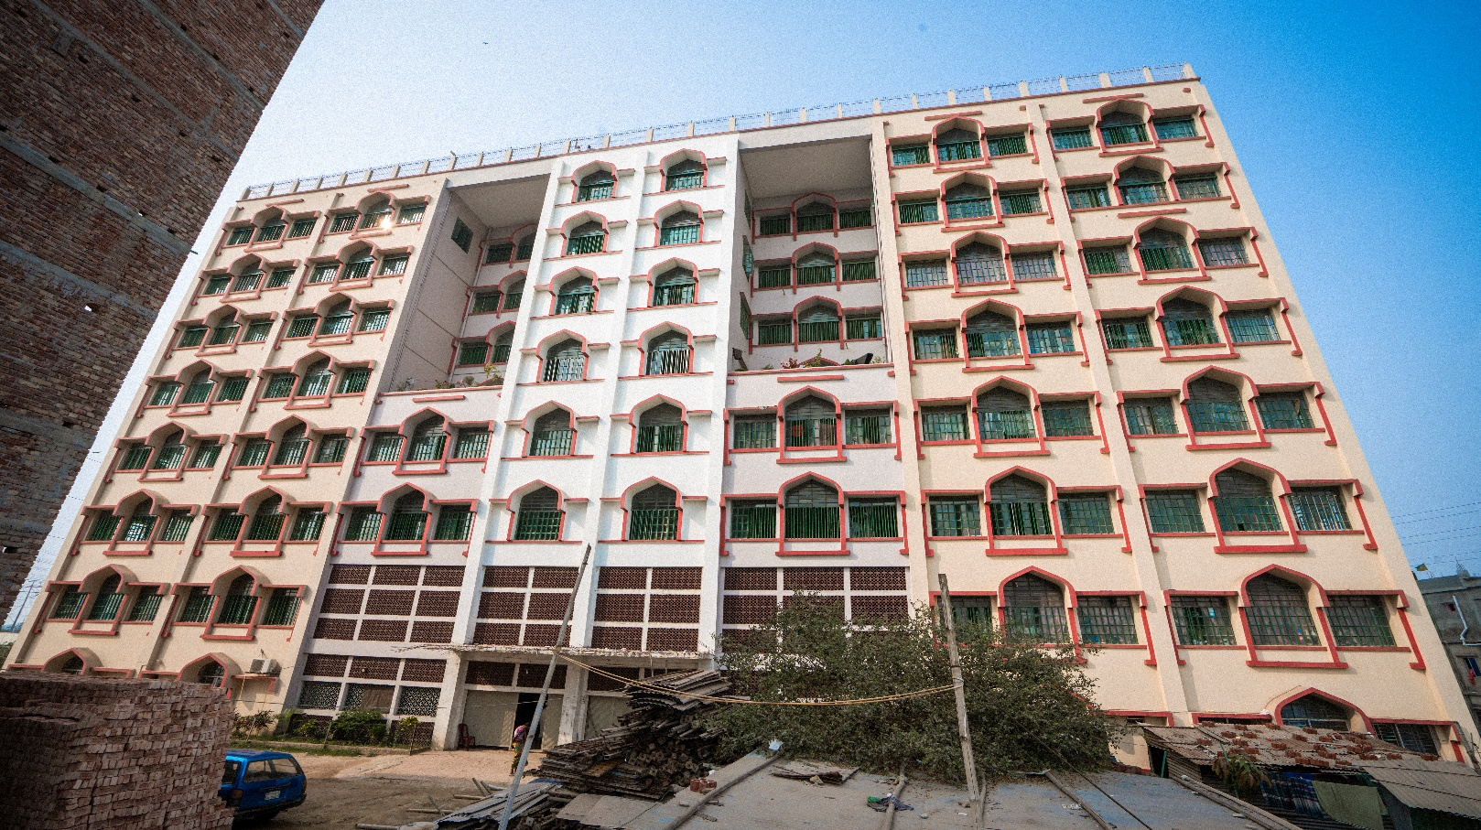

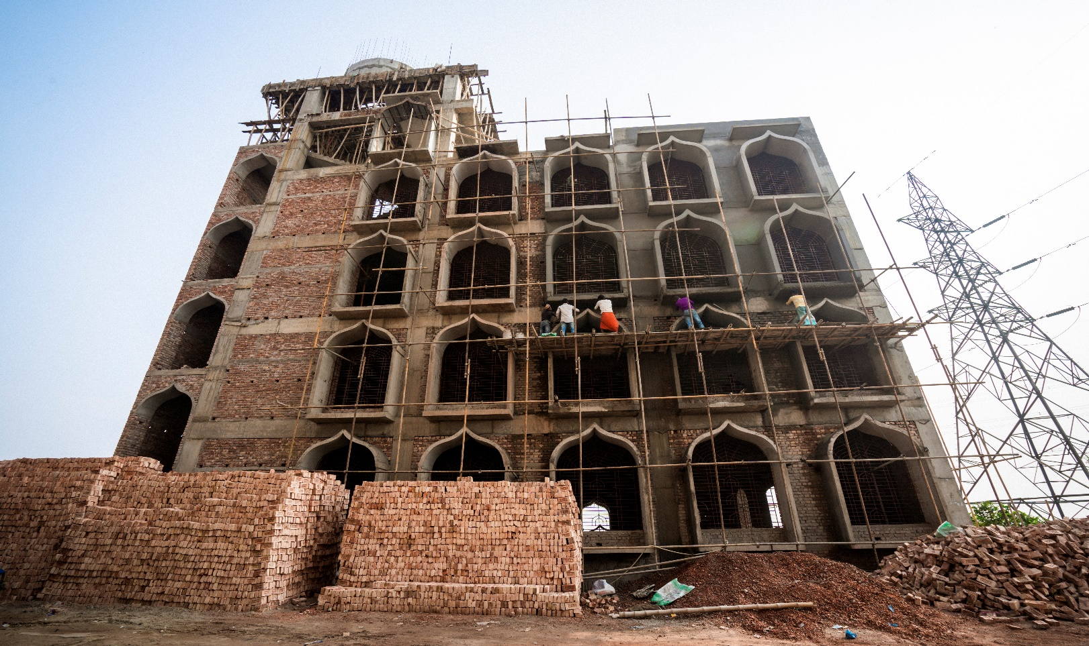

Figure Madrasa at Amin Bazar

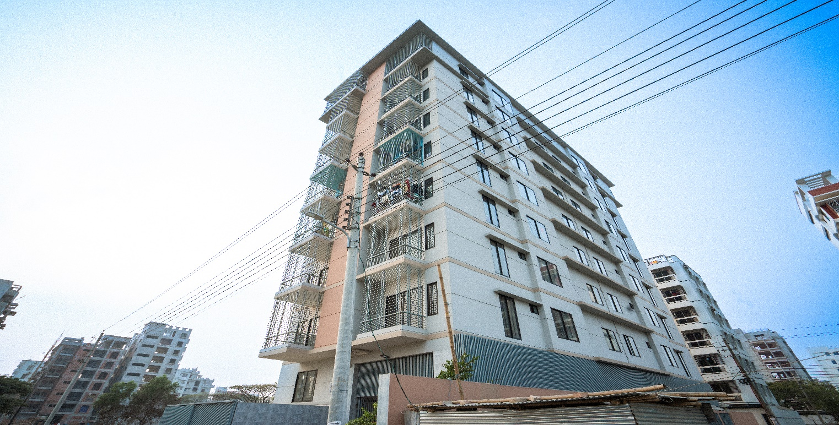

Figure 10 storied building at Bashundhara R/A

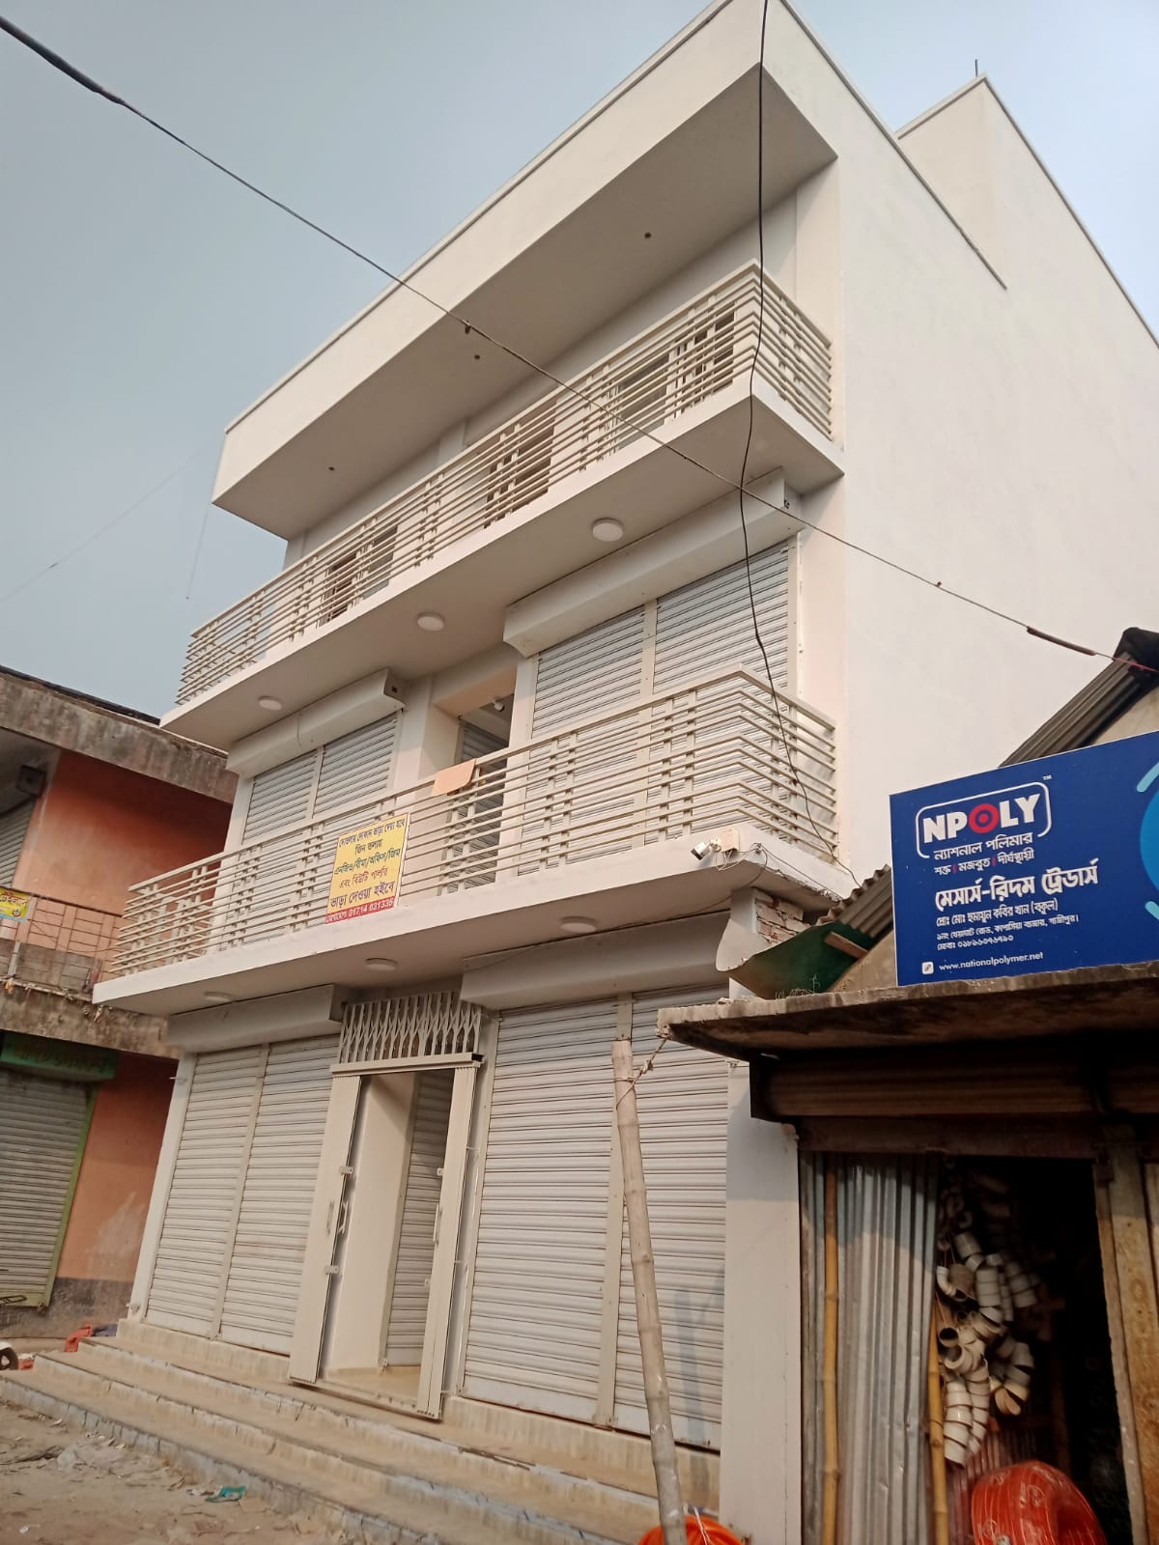

Figure 4 Storied Commercial Building at Kapasia

**6.2 List of On Going Project**

|  |  |  |  |
| --- | --- | --- | --- |
| **PROJECT NAME** | **NATURE OF WORK** | **WORK VALUE (IN CORE BDT)** | **DURATION OF WORK** |
| Construction of 5-storied Mosque building, Aminbazar, Dhaka. | Private Building | 10.00 | 2021-2022 |

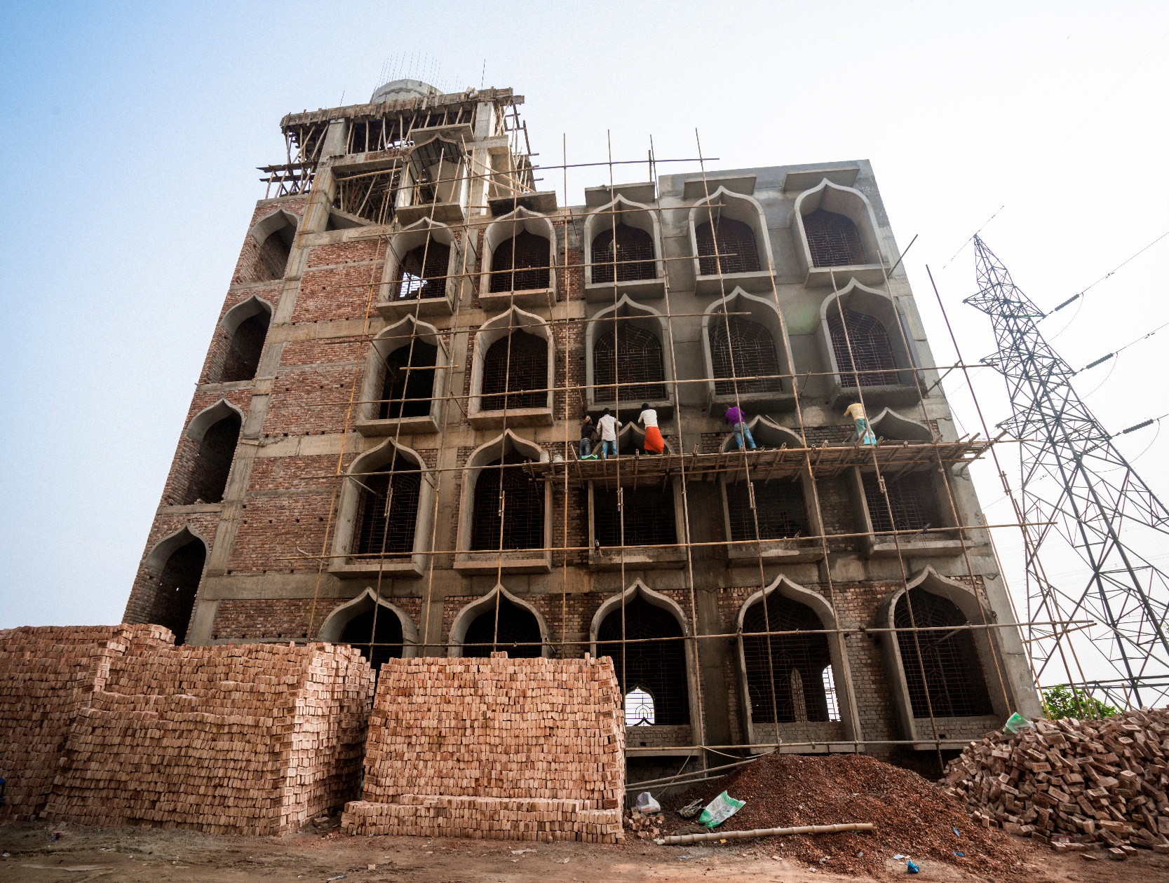

Figure 9 Storied Madrasa at Amin Bazar

**7.0 Management Team**

Trust Engineering & Building Technology believes in teamwork. We feel proud to have a very strong team and we are confident to achieve our goals and objectives with accuracy. We are dedicated to provide most efficient and effective skills in the Country. We are working continuously to improve our system to provide best and efficient services to our clients and also to match with the upcoming days.

|  |  |
| --- | --- |
| 1. | **Engr. Khursed Alam**  **Chief Adviser**  Former Chief Engineer Publics works Department (PWD)  **Education:**  Bachelor of Science in Civil Engineering  Graduated from Bangladesh University of Engineering & Technology (BUET) in 1980. |
| 2. | **Engr. Sankar Kumar Malo**  **Adviser**  Former Superintendent Engineer Publics works Department (PWD)  **Education:**  Bachelor of Science in Civil Engineering  Graduated from The Institute of Engineers Bangladesh in 1989 |
| 3 | **Major Shafiqur Rahman**  **PD**  **Education:**  MBA |
| 4. | **Mohammad Hasan Imam**  **Architect**  **Education:**  B. Arch. (BUET)  IAB Registration/Membership no. 1 – 037 |
| **5.** | **Mrs. Peyara Begum**  **CEO** |

**8.0 List of Trust Engineering & Construction Manpower**

|  |  |  |  |  |  |
| --- | --- | --- | --- | --- | --- |
| **Sl No** | **Name of Employee** | **Designation** | **Qualification** | **Years of Experience** | **Remarks** |
| 01 | Engr M A Kader | COO | B.Sc. Engr. CSE | 15 years |  |
| 02 | Md. Roman Hossain Babu | Manager Engineering | B.Sc. Engr. Civil | 20 years |  |
| 03 | Md. Gazi Golam Sarwar | Electrical | B.Sc. Engr. EE (CUET) | 25 years |  |
| 04 | Md. Munsur Ali | Project Engr. | Diploma in Civil Engr. | 7 Years |  |
| 05 | Md. Abdullah Al Mamun | Assistant Project Engr. | Diploma in Civil Engr. | 2 Years |  |
| 06 | Md. Sumon | Site Engineer | Diploma in Civil Engr. | 5 Years |  |
| 07 | Said Anwar | Surveyor | Diploma in Surveying. | 8 Years |  |
| 08 | Md. Alamgir Hossain | Asst. Surveyor | Diploma in Surveying. | 3 Years |  |
| 09 | Wahidul Murad | Supervisor | SSC | 10Years |  |
| 10 | Md. Abdul Khaleque | Civil Foreman | SSC | 20 years |  |
| 11 | Md. Mofazzal | Supervisor | JSC | 3 years |  |
| 12 | Md. Anowar | Electrical Foreman | SSC | 15 years |  |
| 13 | Md. Abdul Karim | Asst. Electrical Foreman | SSC | 15 years |  |
| 14 | Md. Monir Hossain | Welder | PSC | 5 years |  |

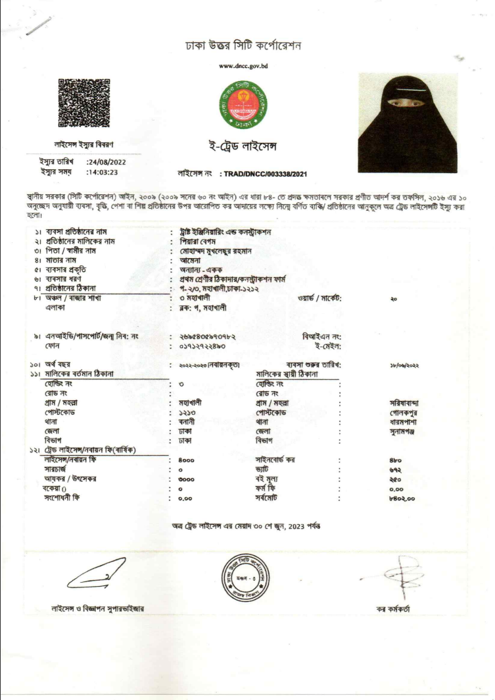

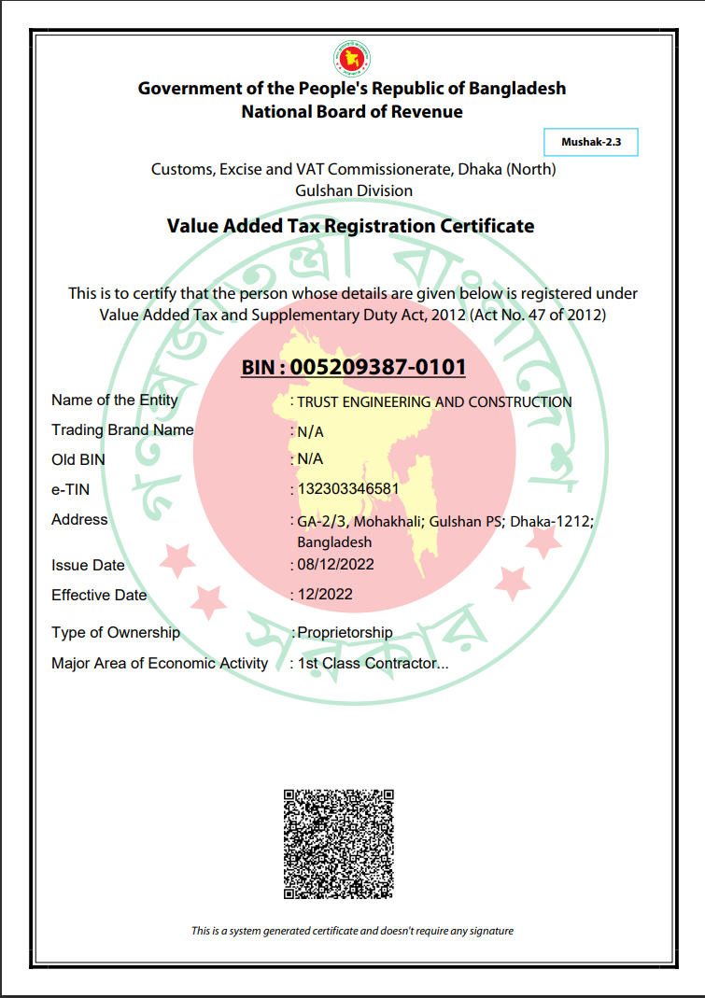

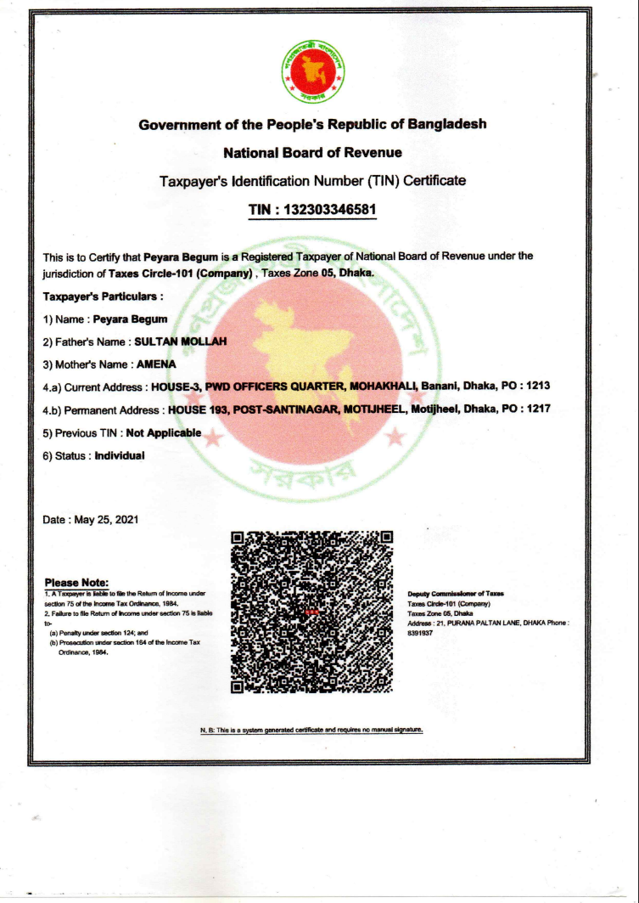

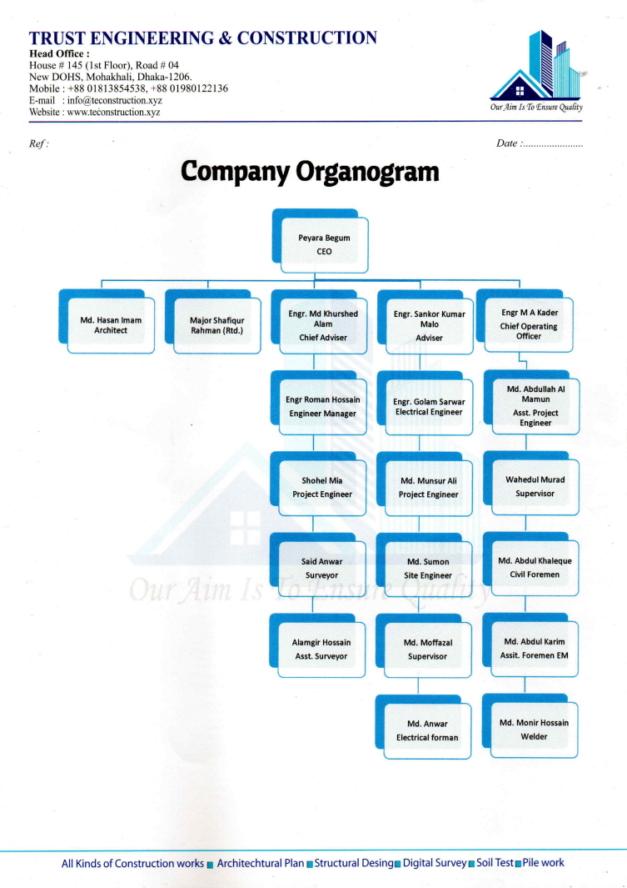

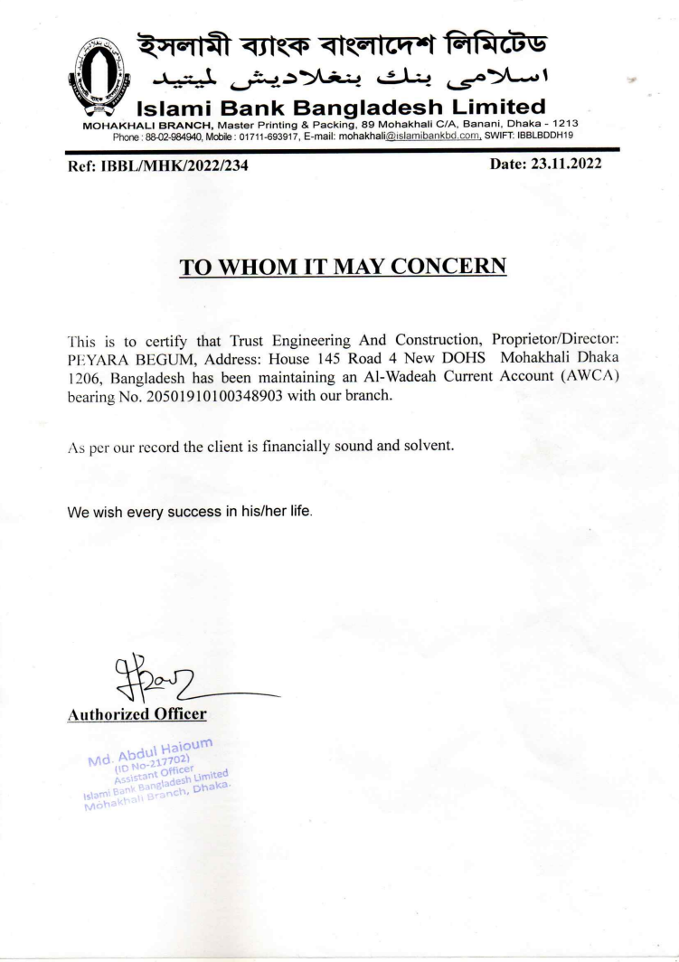

Our development goal is to create a best respond to the needs of the user and the best Project as oppose to changing, the natural beauty of each unique Development. Our design solutions create a best Development that sustains itself, by designing low-maintenance cost, using resources such as slope, material and water, efficiently, and using native and drought-tolerant plants. Our previous projects include a big project like Bashundhara R/A, Amin Bazar Jame Mosque, Construction of 4-storied Shopping Complex building, Kapasia, Construction of 10 storied Residential building Tejkonipara, Tejgoan, Dhaka, Gazipur, Construction of 9-storied Residential Madrasha building, Aminbazar, Dhaka. and more.

**Thanks**